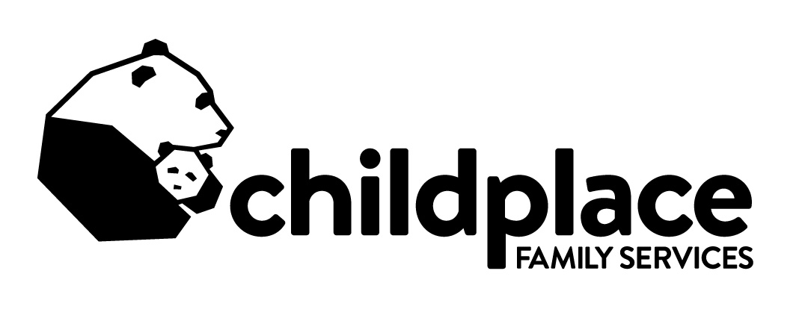
List of Needs (Residential):
(For clients living on campus – mostly teens)
Shampoo/Conditioner – 2 in 1
Body wash (for guys and girls)
Deodorant (for guys and girls)
Colgate toothpaste
Toothbrushes
ALL unscented liquid laundry detergent
Fabric softener
Dish washing soap (liquid)
Dishwasher detergent
Gallon zip-lock bags
Quart size zip-lock bags
Tall kitchen trash bags (13 gallon)
Bleach/Germicide cleaner
Disposable vinyl gloves
Plastic plates, bowls and cups
Forks and spoons
Tupperware type containers
Totes
‘WET’ brand hairbrushes
Feminine products (pads/tampons)
Boxer underwear – various sizes
Heavy duty shower curtains in neutral colors (not clear)
Twin size sheets
Pillows
Alarm clocks
Beach towels for pool visits
Bath towels/Wash rags
Kitchen hand towels/rags
Aprons for staff
Large skillets
Large pots
Teflon kitchen utensils
Socks – white (adult sizes)
Board games/card games
Basketballs
Soccer balls
Footballs

Kick balls
Frisbees
Baseball gloves
Tennis Balls
Bike helmets (adult size)
Waterproof gloves for snow
School supplies

List of Needs (Foster Care):
(Ages infant to approx. 18 years old)
Riding toys/scooters/bikes
Helmets (elementary age or younger)
Balls/sports equipment
Batteries
Canned drinks
Bottled waters
Juice box drinks
Paper products
Goldfish and similar snacks
Small bags of chips
Weighted blanket or shawl
Diapers/Pull-ups
Baby wipes
Cribs/Pack-n-play
Highchairs
Sippy cups
Baby tubs
Backpacks/Diaper bags
Car seats (all sizes)
Diaper pails
Sheets and bedding/crib size
Sheets and bedding/twin size
Baby carriers
Sensory toys like chewies
Clothing for older children (Age 8-12 years)
Lunch boxes
School supplies/books
Picture frames (for families to use as keepsakes)

